**S3 Bucket**

**Step 1:**

Create an AWS account and select S3 bucket in the services.

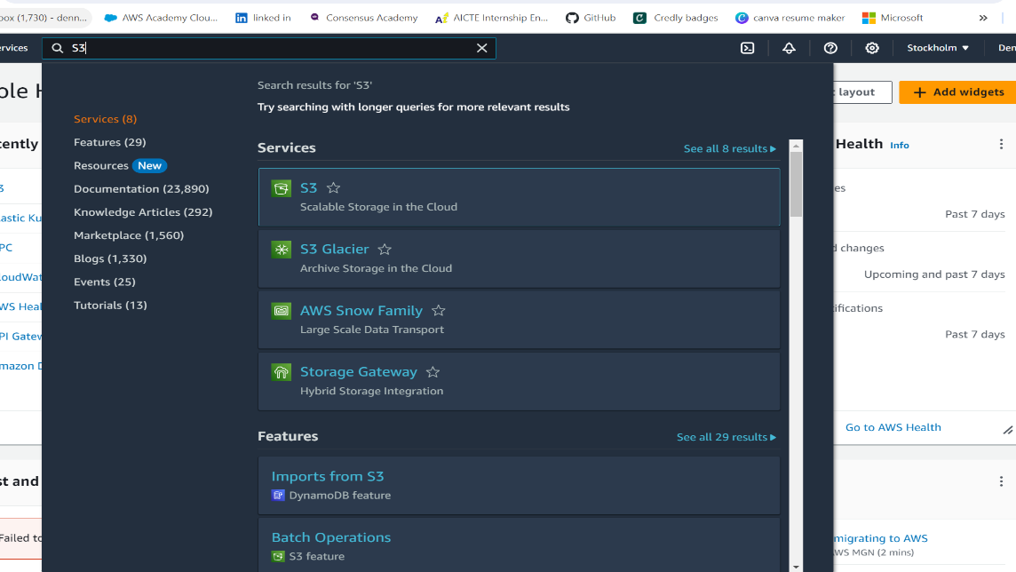

**Step 2:**

Select S3 bucket and click on the create bucket button at the top right Corner.

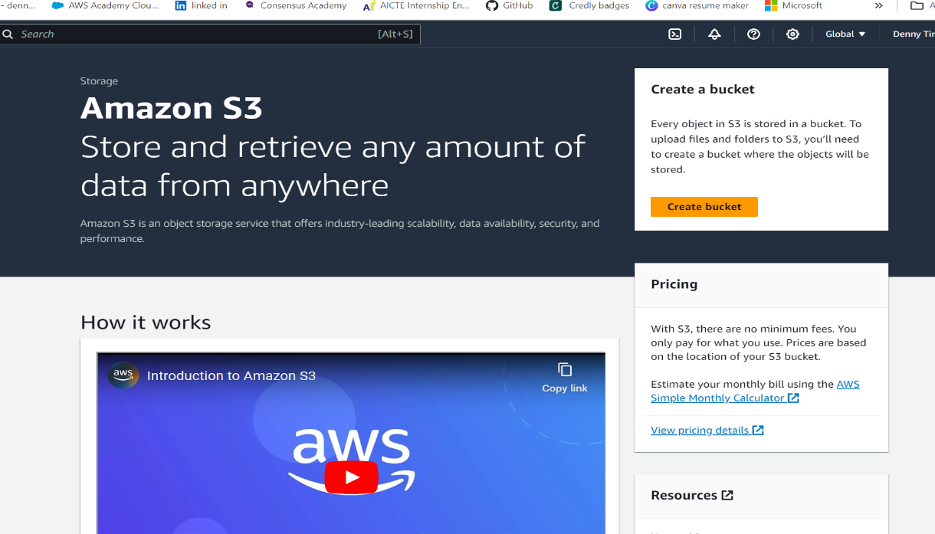

**Step 3:**

Enter bucket name and choose enable for bucket versioning Other options are set as default and click on create bucket.

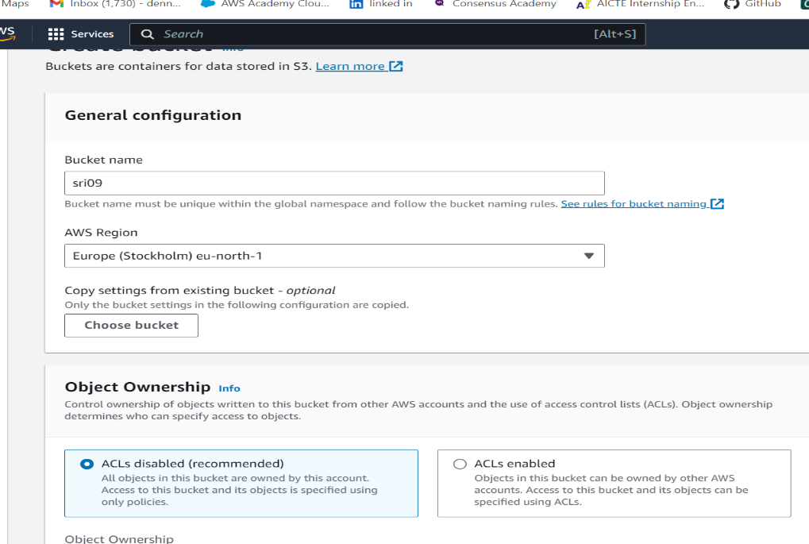

**Step 4:**

Then Bucket successfully created with the given name.

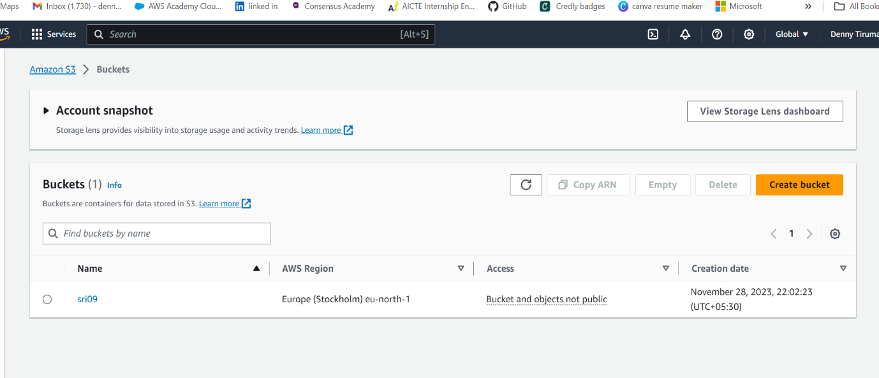

**Step 5:**

Click on the bucket name and then select the upload option.

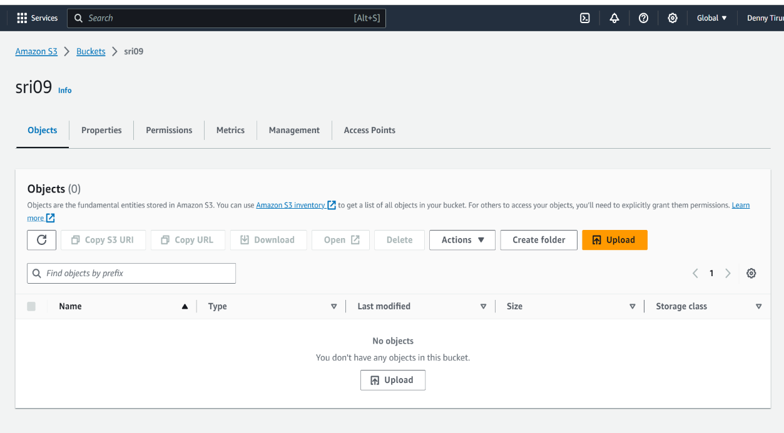

**Step 6:**

After select upload option Select add files and add any file into the bucket which is in the device and click on upload then the file is successfully uploaded in the bucket. After that close the bucket.

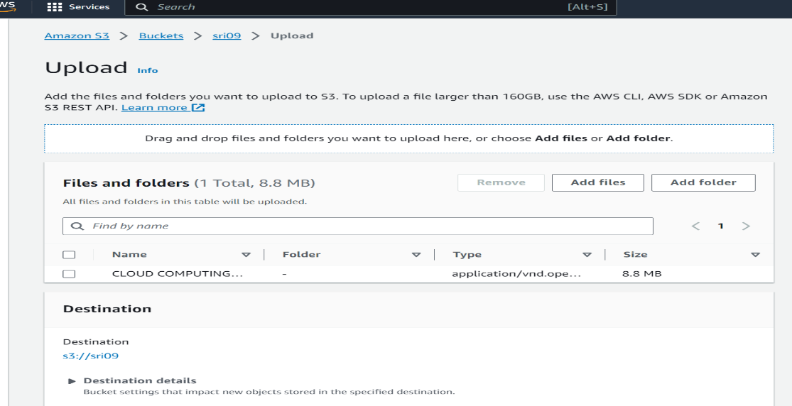

**Step 7:** Again, select the bucket and download the file from the bucket. If the downloaded file is same as uploaded file the bucket works properly.

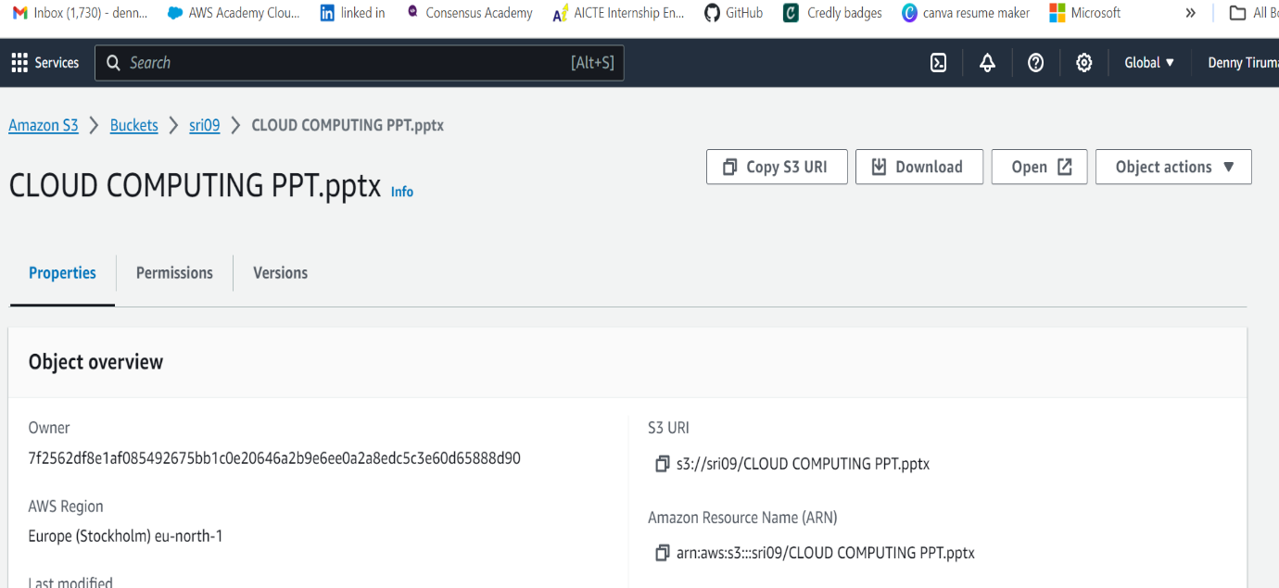

**Step 8:**

Again, select the bucket and click on empty and write permanently delete and exit. After that delete the bucket by clicking on delete option and reenter the bucket name.

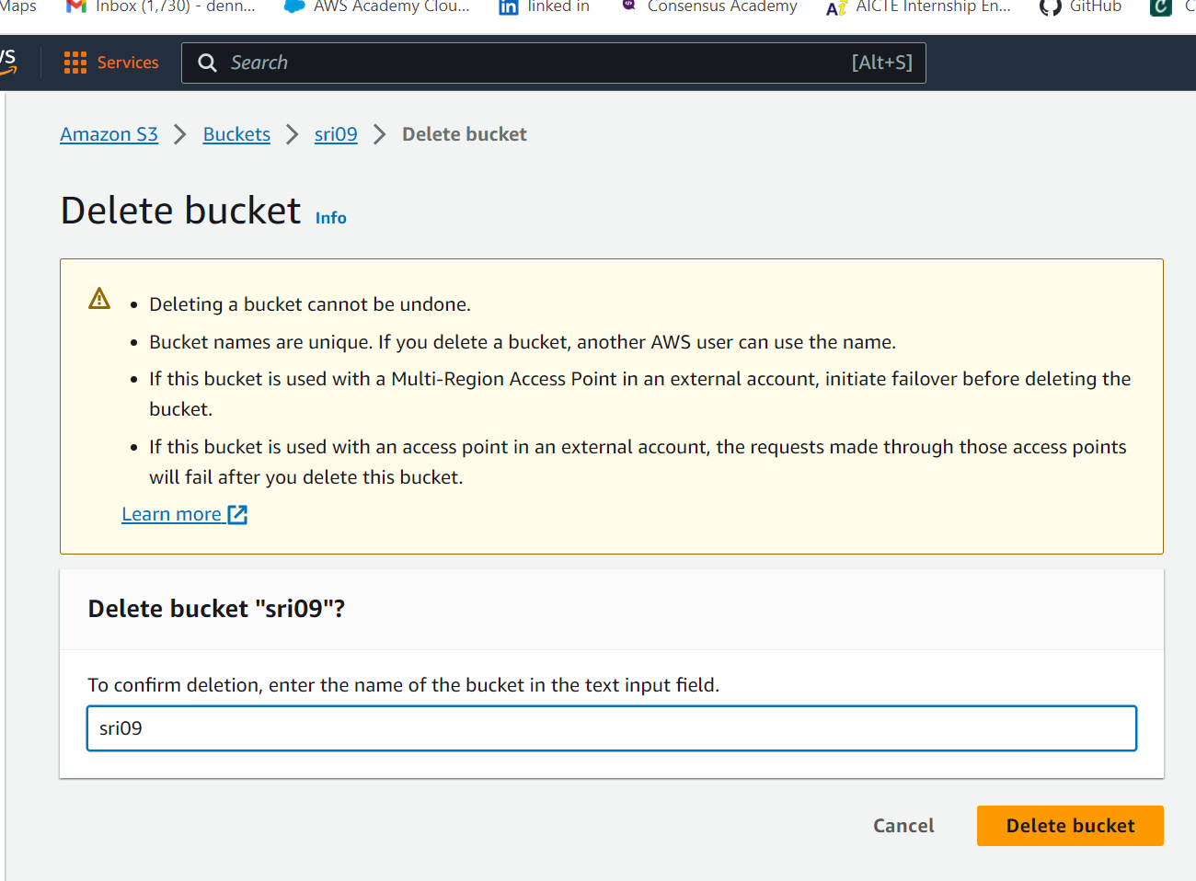

**Step 9:**

After clicking on delete bucket bucket is successfully deleted.

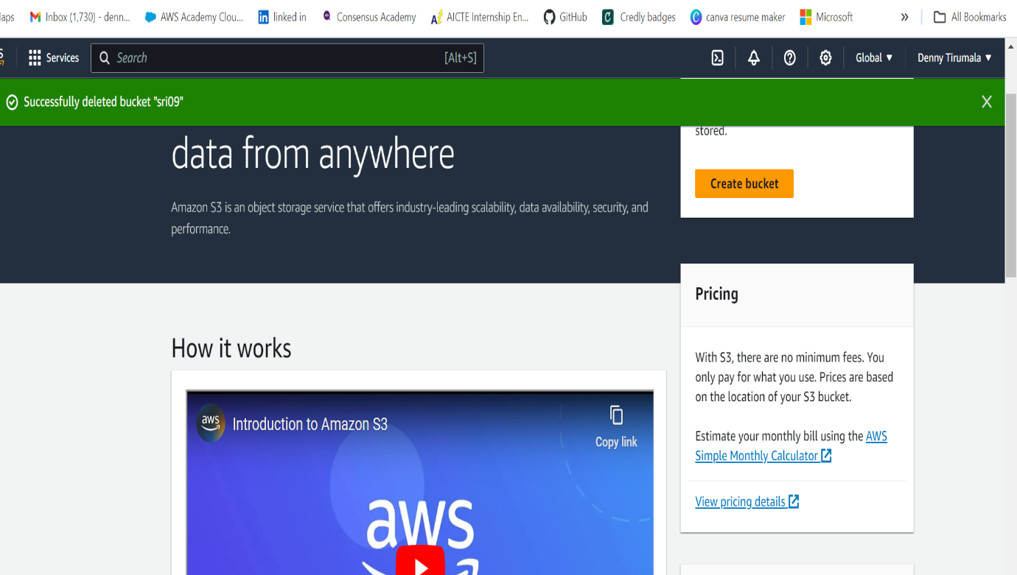

This is the process of Upload a file ,download a file, delete a file from S3 bucket in AWS.